Learning Log Tasks for Sky classes.
Autumn Term 2
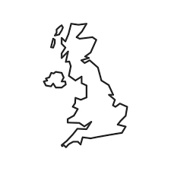
Island to Isle.

Feel free to carry out the below activities in any order. Learning logs will be sent home on a Friday and please hand them back in on a Tuesday if you have completed any work.
Activity 1: Choose one of these animal groups: mammal, amphibian, fish, bird or reptile. Think about what animals in this group are like. Do they have scales or fur? Do they live on land or in water? Design your own brand new animal that would be part of this animal group. Choose the parts your animal has carefully to make sure it fits its animal group, but be creative! Draw a picture of it when it is young and when it is an adult.

Activity 2: Create a firework picture. You could use paints, pencils, technology- ANYTHING!

Activity 3: In Maths, we will be working on addition and subtraction. Play some of the games on Top Marks Maths: https://www.topmarks.co.uk/Search.aspx?Subject=16 Hit the Button is particularly good for working on number bonds and number facts.

Activity 4: Can you make a Christmas decoration to help decorate our classroom? It could be for the tree or somewhere else!

Activity 5: A Noun is a naming word. Give yourself 60 seconds to looks around the room and spot as many nouns as you can. Can you write them in a list too?

Activity 6: Write a book review for a book you have read recently. Who wrote it? What happens in the story? Would you recommend it to anyone?

