Learning Log Tasks for Sky classes.
Summer Term 1
Sizzling Seaside
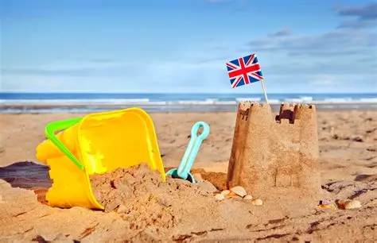

Activity 1: This term we will be learning about the Victorians. Can you find out about Queen Victoria? Write down some facts that you find out.

Activity 2: We will be looking at the lives of Victorian children. Can you write a diary about your weekend? We will compare your life to a Victorian child.
Activity 3: Go on a minibeast hunt in your garden, a park or outside space. Look for creatures like worms, ants, spiders or beetles. Describe where you find them (under a rock? In the grass?) Make a simple tally chart to keep track of what you find.
Activity 4: Choose a minibeast (butterfly, ladybird or frog) and learn about it’s lifecycle. We did this in Science last term so see what you can remember.
Activity 5: Let’s practice our money skills! Have a play on Top Marks Maths: https://www.topmarks.co.uk/money/toy-shop-money

