Learning Log Tasks for Sky classes.
Summer Term 2
Sizzling Seaside
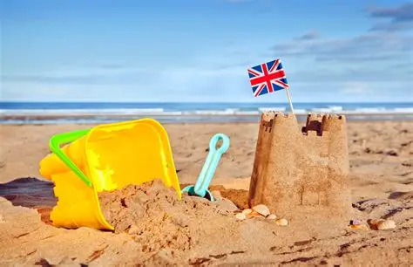

Activity 1: Science – Amazing Inventions
This term we are learning about how inventions have changed our lives. Choose the gadget you think is the greatest invention ever (e.g. phone, television, computer, tablet, games console). Research it and find out key facts: Who invented it? When was it invented? How has it improved our lives? Present your findings in a fact file with pictures and simple sentences.
Activity 2: English – Seaside Postcard
Write a postcard to your favourite person telling them about a seaside visit. Remember to use conversational language and expanded noun phrases (e.g. the sunny, golden beach). Include capital letters, full stops, and commas to separate adjectives. Describe what you can see, hear, and do at the seaside.
Activity 3: Geography – My Route to School
Draw a map of your journey from home to school. Use your Ordnance Survey map skills and include a clear key. Label physical and human features you pass (e.g. parks, rivers, roads, shops, buildings). Make sure your map is clear, detailed, and correctly labelled.
Activity 4: R.E – What Makes a Good Friend Recipe
Create a “recipe” for what makes a good friend. Think about important qualities such as kindness, honesty, and respect. Use time conjunctions such as first, second, then, next, and finally to structure your ideas. You could present this as a recipe card or poster.
Activity 5: Maths – Positional Language Shapes
Draw or build a collection of 3D shapes (cone, cube, sphere, cylinder, etc.). Describe their positions using correct positional language. For example: “The cube is to the left of the cone” or “The sphere is above the cylinder.” Try to include as many accurate positional descriptions as possible.

